Automated Movie Recommendation System
(Good Movies)

Supervised By: Mr. Qublai Ali Mirza
(Lecturer at National University of Computer and Emerging Sciences)
Name | ID | Section
Rafay Farooq | K112257 | A
Usama Noman | K112119 | A
Hani | K112190 | A
Asad Tanveer | K112090 | C

Contents
Supervised By: Mr. Qublai Ali Mirza 1
Introduction: 4
Project Scope: 4
Overall Description: 4
Target Audience: 4
Why we Need AMRS? 4
System Overview: 5
Number of Users: 5
Types of Users: 5
Technical Level of Users: 5
Access Right: 5
Initial Data: 5
Network Requirements: 5
Maintainability: 5
Data Requirement 6
Functional Requirements: 7
Core Features: 7
Additional Features: 7
Functional Analysis: 8
Use Cases: 8
Data Flow Diagram 11
Context Level: 11
LEVEL 0: 12
LEVEL 1: 13
Software Design Specification: 14
Class Diagram:- 14
Sequence Diagram: 15
State Diagram 18
Activity Diagram: 21
ERD (Entity Relationship Diagram) 23

Introduction:
This document will tell the readers about out new system named “Automated Movie Recommendation System”. We will use the terminology AMRS in our document for our system and describe all its system requirement specifications details in it. The main purpose of this document is to provide and facilitate the system analyst and designer the main and key features of the system on which the foundation of whole system will be maintained. The document will cover hardware, software and other specification requirement which may be useful for feature use and help to support the technical dependencies.

Project Scope:
The system will use PHP platform for its logical implementation and database storage, HTML5, Javascript, CSS3, and JQuery are other tools for user interface. The main system will run on the client side and a database will be maintained on the server side on the basis of which the recommendations are being generated.
The system is design to facilitate the users about the updates of newly released movies or inform them about the movies which they may like to see. The AMRS will decide the flavor of the user by maintaining and observing some key data user will provide intentionally or un-intentionally. Potential scenarios include, registration on the system, rating the movies, providing feedbacks and search or browse for different movies.

Overall Description:
The Automated Movie Recommendation System will provide users, the notification about the movies they may like based on their interest and activities they perform on the system. The system will monitor each potential scenario user do when he is on the domain of the system. After applying some efficient algorithms on these raw data, we will have some efficient information about the taste of the user. Based on the likeness factor calculated by the system, the automated notifications will be generated for the users.

Target Audience:
The app will be design for all those people who love to watch movies and want to give healthy critics. The system will not be gender or age specific but will target all the movie lovers no matter to what age group they belong.

Why we Need AMRS?
There are many web-sites where movie lovers can see the ratings and rate different movies. But there are very few applications which notify the user automatically when a movie based on their interest released. In addition, there are fewer than few websites, who generate user activity data and utilize it for better purposes like generating trends etc. Our system will have the uniqueness to be the smartest system which keeps track of each and every detail user put on the system and manage it very efficiently and use it very efficiently.

System Overview:

Number of Users:
The system can be used by many users at a single time. As it’s a web based app and can be access worldwide so we can expect very few to very large number of visitors at any specific interval of time.

Types of Users:
The system can either be accessed by a movie lover, or by a professional who provide critics to movies or by any film industry personal.

Technical Level of Users:
The technical level of user can be measured between 1 to 6 where 1 being the newbie and 10 being the expert. We are not expecting any professional computer experts to visit our website so the users who visit the website have the general knowledge to surf the web pages on the internet.

Access Right:
There will be two access right panels, one for ordinary users who will visit the web to get the information and for rating and second for the administration personal who keep the tracks of trend and data generated by the user activities. Apart from admin, there will be a moderator who will moderate the comments and feedback user provide. The moderator will not have complete access of the web but have access more than an ordinary user.

Initial Data:
The initial data present on the web will be already rated films. The source from which we extract this data would be reliable so there is no question of fake population of data. There might be some change in the content details, but rating would be same and changes after the interaction with user.

Network Requirements:
Internet connection is necessary to access the latest up-to date information from the web. The website is accessible through mobiles because of its responsive design and also through different tablets and PC’s.

Maintainability:
The system will be maintained by different administrators and moderators. We are planning to include more futures with the passage of time but initially the system will be maintain by in-house team and no external human resource will

Data Requirement
We have the following entities in our AMRS
- Movie: This is the most important entity of our system on the basis of which our whole system executes and revolves around. It will have the following entities
  - Name
  - Cast
  - Language on which it is released
  - Duration of Movie
  - Type
  - Category
  - Released Date
  - Rating
  - Director
  - Cast

- User: This is another interactive entity which will give some input to our system and in return receive some output. This is the only entity for which the whole system is maintained. The key attributes of this entity would be
  - Name
  - Email
  - User ID
  - Gender
  - Year of Birth
  - Country
  - Zip
  - Password
- Administrator: This is the entity which has the authority to maintain the system decorum and make it a useful place for others.
  - Name
  - Email
  - Admin Id
  - Gender
  - Country
  - Password

- Moderator: Moderator will be analyzing comments and user activities and have the responsibility to maintain the decorum of the forum. He will have the following attributes
  - Name
  - Moderator Id
  - Email
  - Gender
  - Country
  - Password

Functional Requirements:

Core Features:
- User Registration
  - This log-in screen will appear once at the time when user first visit the session of the web-page. User has a choice to either log-in or remove the session and directly jump into the main session of the web page.
  - It allow user to get the notification on their emails.
- Movie Rating
  - It allow user to rate the movie based on his own preference and choice.
  - It will help the system to generate the taste and flavor of the user.
  - Based on the data generated by the ratings user provides to different movies, the user will notifications.

- Movie Search
  - The system will facilitate the user to search the movies by year, cast, language and type.
  - It will also facilitate the user to generate the data of what type of movies being searched by the user and help to generate notification.
  - It will also provide the data to be estimate as which movie has been searched by the users and provide a general trend.
- Movie Feedback
  - The users are allowed to post their feedbacks and comments about the movies they have watched.
- Email Notification
  - The users will be notified if any movie which may be like by them is released or going to be released.

Additional Features:
- Multiple user notification
  - It should be able to send notifications to multiple users.
  - It also suggests movies on the basis of what our friends and circle have rated or seen.
- No In-Active People
  - We will not send any notifications to people who do not log-in to the web for more than a month.

Functional Analysis:
We will illustrate the functional analysis which helps us to understand the functional requirements and interaction of user with the system. Our system will have the following entities which will interact with our system and perform some transactional operations.

Use Cases:
Movie Recommendation System
Description:
This use case diagram elaborates the interaction of our most important entity Movie Recommendation System. It will have the following activities
- Track User activities
- Generate User interest based on User activities.
- Generate Recommendation.
Each use case is divided into sub-activities which are the essential parts of fulfilling the specific use case on efficiently and properly.

Administrator/ Moderator
Description:
Both moderator and administrator are the key entities defining the main structure of the system. They are responsible to
- Update Movies Database
- Modify Feedbacks
A number of sub-task will be perform before completing the desired use case like to update movie database; Administrator has to add all the necessary details in order to fulfill and satisfy all the table constraints.

User:
User is the most and the only entity which access our system from outside. It is an external entity for which the whole system is to be maintained. User will be given certain functionalities in order to interact with system and facilitate with it. Some key functionalities are rating movies, providing feedback and search movies.

As we know that the use cases are high level graphical representation of the system. To be more specific and discrete, we will describe the data flow of our system through Data Flow Diagrams. In the next section, we will have DFD’s of our system which elaborate how the system data is being flown and interacting with different entities and what are their usage and importance in the system.

Data Flow Diagram

Context Level:
This is the highest level illustration in DFD which explain the overall data stream between a single main process.
Movie
Recommendation
System

USER
Administrator
Register
Login
Rate movies
View Details
Provide Feedback
Modify Feedback
Add Movies details
Send Notifications
Moderator
Approve/Disapprove Feedback

Get un-approved Get Feedback

Get Feedback

Description:
This is the context view of our system and describes how data is flow on the system. As already discussed, out three main entities are interacting with one process. All the external entities are providing some input to the system and receiving some output. We will describe these data flows in more detail at Level 0 and Level 1 where our main process will be further divided into sub processes.

LEVEL 0:
At level 0, the system is divided into 6 main processes. The entities that interact with the system are
- User
- Movie Recommender
- Administration
- Moderator
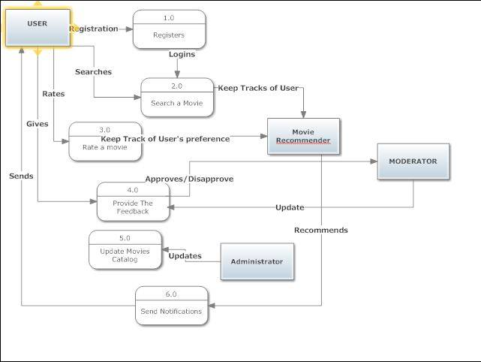
Description:
The user will register him/her. After registration, user will login. Then user has the options to either search or rate a movie. The user will also be provided with a feedback form to record his/her feedback.
Movie recommender will keep track of user’s preference by keeping track of users search history and the movies been already rated by the user on the basis of which, it will send notifications to the user in the future For e.g. upcoming movies that a user may like to watch, suggest it to a friend etc
The administrator will update the movie catalog from time to time and will maintain the site.
Moderator will approve or disapprove the feedback forms submitted the users.

LEVEL 1:
At Level 1 the processes in level 0 diagram are further decomposed into sub-processes. At first the user registers him/her by selecting an appropriate username and password. After verification the user registration process completes.
The administrator and moderator have to login as well so both of them are also assigned a user name and a password.
Once user enters the system, he/she can use different features of the system such as search or rate a movie.
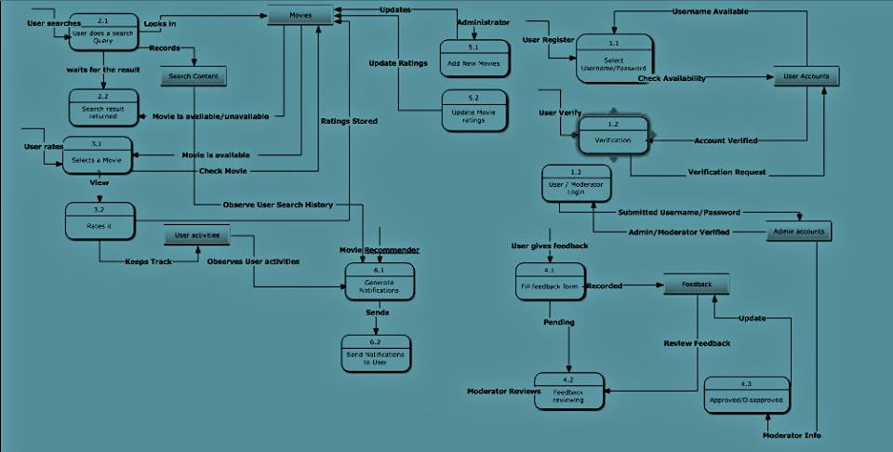
The data stores used to record different type of data are
- User Account : It will store user’s information
- Admin Account: It will store information regarding moderator and administrator
- Movie : It will record movie names
- User Activities: It will keep track of movies already rated by the users
- Search Content: It will keep track of user’s search history
- Feedback: It will record feedback forms of the users
For searching, the user types a search query in the search bar and the appropriate result is returned to the user. For rating a movie, the user will select a movie (provided that it’s already in the database) and rate it accordingly to his/her likes and dislikes. During all this time the movie recommender keeps track of user activities and records it in the data stores. The future recommendations are also sending on the basis of these activities. Meanwhile the administrator updates the movie catalog and movie’s latest ratings. The moderator reviews the feedback and then approves or disapproves the feedback forms submitted by the user. The system also records the information about the moderator whenever he approves or disapproves a particular feedback form.

Software Design Specification:
After the detail analysis of Software Requirement Specification, we will now move forward for Software Design Specification in which we discuss in more details the design and specification of our system. In addition with that, we will discuss and view out system design through different analysis tools and diagrams.

Class Diagram:-
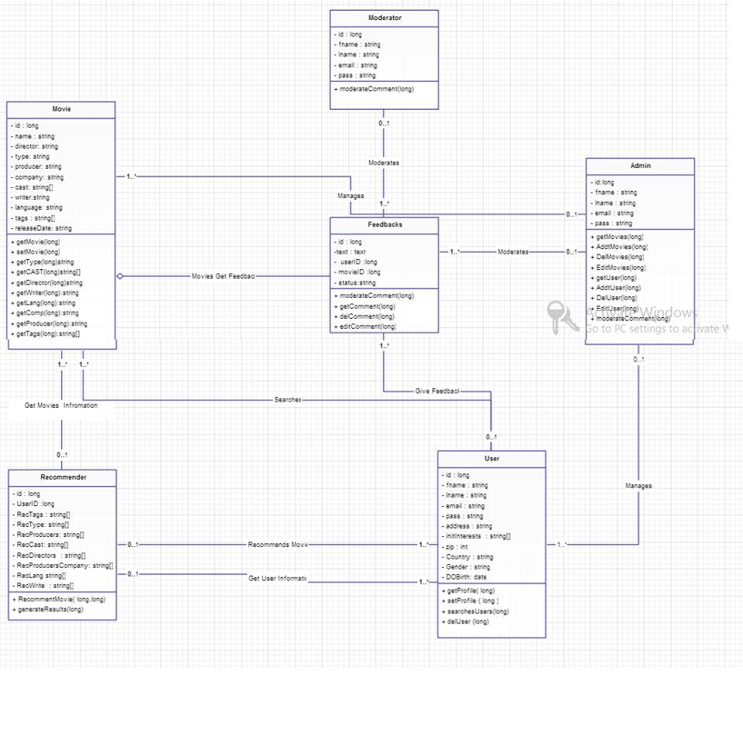
This class diagram indicates the relation between different entities present in the system. Apart from some core entities, we have Movie and Recommender acting as an entity having the attributes discuss in Data Requirement and Analysis.

Sequence Diagram:
We have already defined how data is being flown on our system, now to illustrate the sequence of execution of process; we define the sequence flow of our data through Sequence Diagram. Following are the sequence diagram of each use case we have defined in our Software requirement specification.
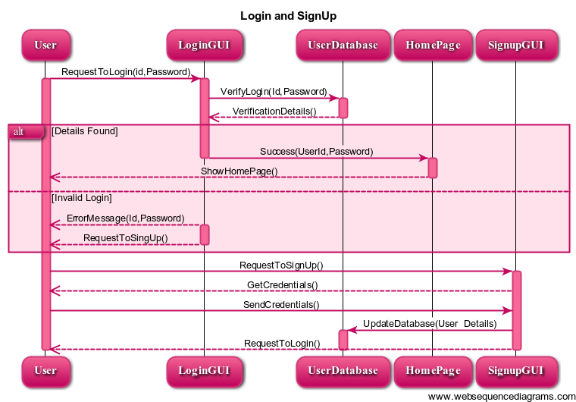
User log-in after its credentials is verified from the user database. Once the credentials verification email is sent to the homepage, the homepage will be shown to the user.
User can also search/view movies already updated on the database. Because our system is maintaining the track of user searches, rating and feedback that’s why all the movies user visit will be track and recorded by our Recommendation System.
Likewise, when user searches complete, user can rate movies which is being tracked by the Recommendation System.
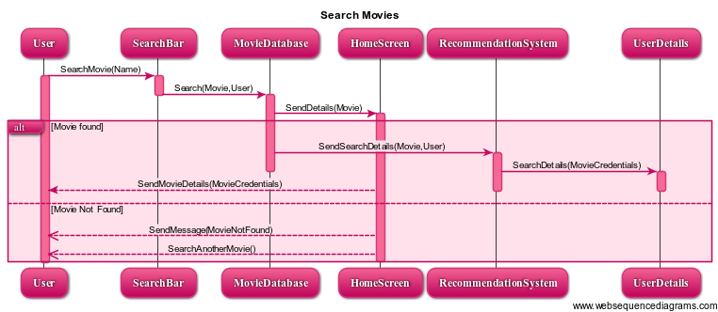

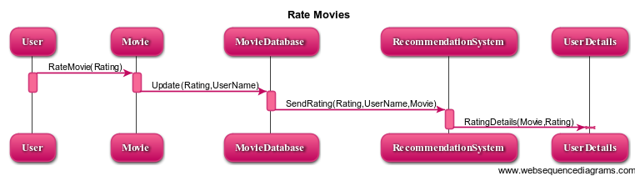

After rating user can also have the facility to provide feedback of the movie he/she have watched. These feedbacks have also been track by the Recommendation system and ultimately help in Generating flavor of that particular user.
The feedbacks are moderated by Administrator and Moderator at the time when they submit it. No comment will be posted live until moderator or Administrator Approve/Disapprove it. In addition, the administrator has the responsibility to add new movies and keep the movie database up to date. Any subject to change in any movie information must also be change by the Administrator.

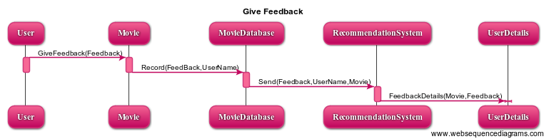

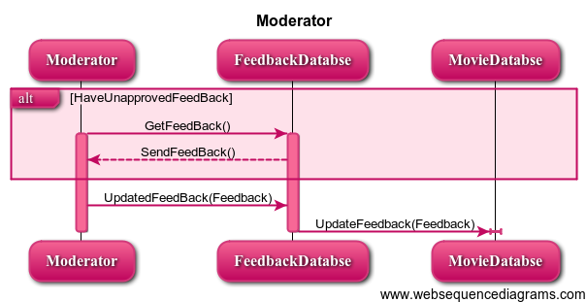

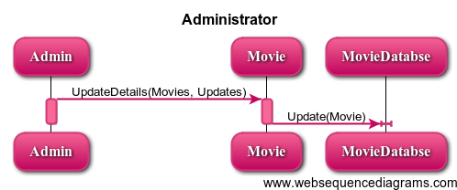

The last and the most important step in which the user flavors are generated on the basis of Rating, Searches and Feedbacks. The final output will be shown as a recommendation o n that user wall.

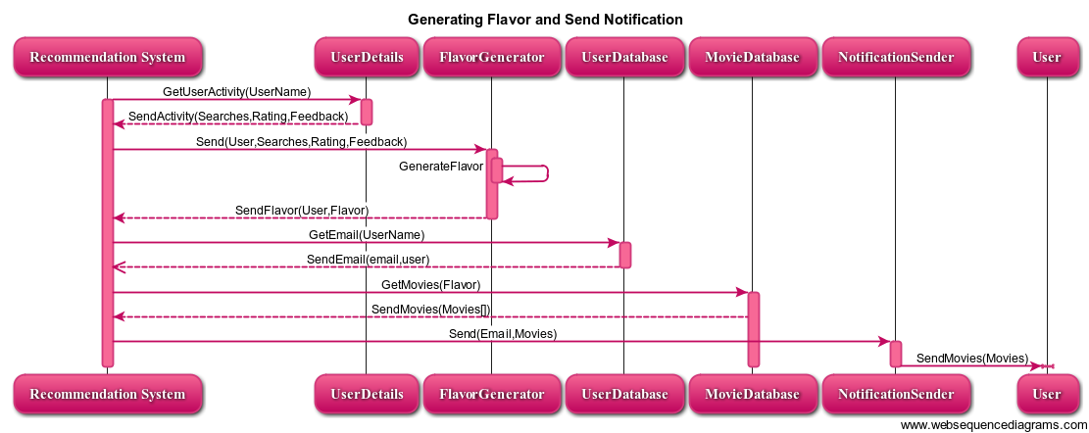

These sequence diagram is the more described form of the use case we have described in our earlier part of the report. In the next phase of our report, we will define how the states of our system changes on the basis of which transitions.
These state diagrams are very important and illustrate that how our system states have been changing and what data triggers these changes.

State Diagram
The state diagram show the journey o user, he/she will first have to register himself, after this he don’t have to repeat this step but login every time he visits the website, If failed then he will be prompted to re-enter id and password. After logging in he can perform various activities including searching movie, providing feedback and rate movies.
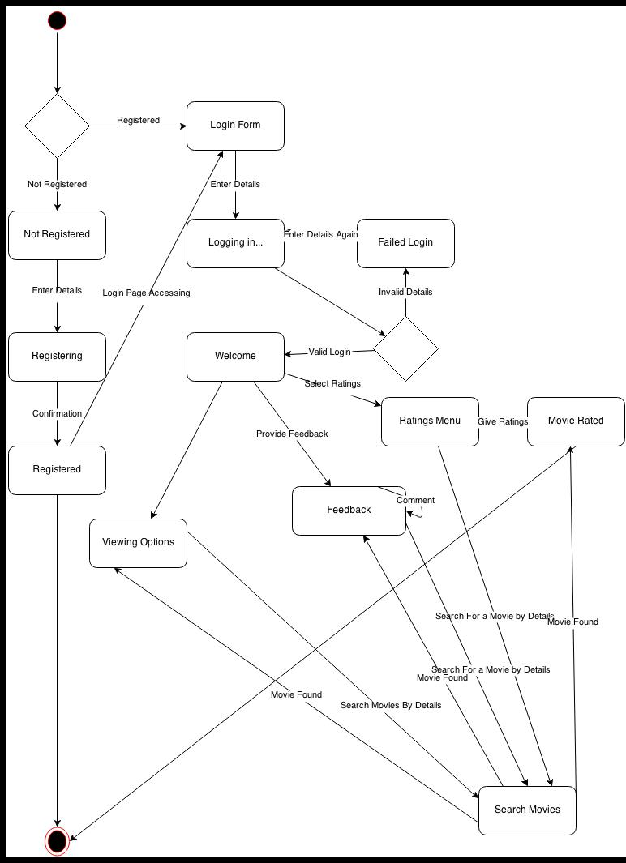

The state diagrams describe the behavior of website by admin and moderator, administrator can update details related to movies as well as modify feedback and moderator can accept or reject feedback.

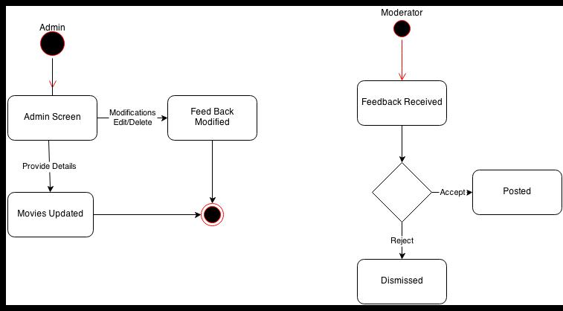
The last state diagram shows the role of system in movie recommendation system. As describe the system can track user activities and provide with relevant details, the system can also provide a general user behavior by making use of user track record and the last functionality include giving notification to user by sending emails.
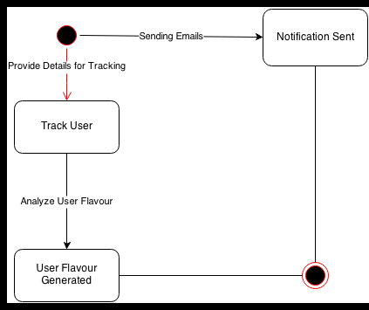

Activity Diagram:
Activity Diagram describes the activity between different states. So we will discuss different activities between the users, recommendation system and administrator. Although they are much similar with State diagram, but they are different and made for different purposes.

ERD (Entity Relationship Diagram)
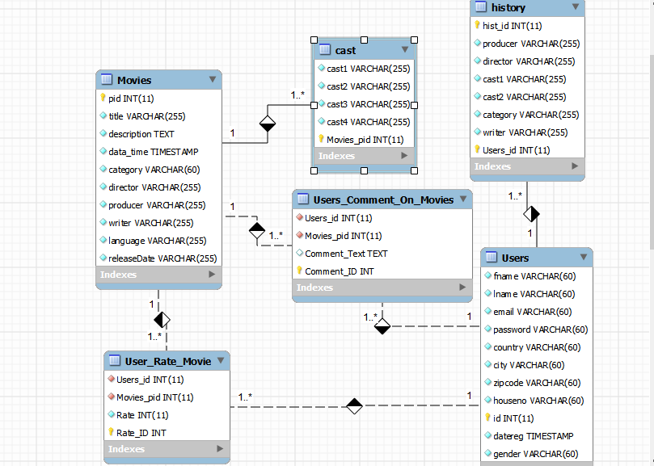
This ERD explain the relationship between our main entity tables. One user can comment on many movies and also can rate more than one movie. Similarly, one move can have more than one ratings and comments and so on.

